NIA (Next Intelligent Agent)
It is a role based platform to manage AI agents across organization
The system is built using FastAPI with Python, uses SQLAlchemy with PostgreSQL, and follows REST APIs with OpenAPI specification.
2 interfaces- Admin and Chat Interface
So basically, there are 60-70 agents in our application, and each agent has there own responsibility to do their work, like Code Helper is one of the agent where we can ask coding related question, Email Assist, so if you want to write any email for any topic so in that case you can use Email Assist etc, so we can use these agents by creating a team in the admin application. So, according to the team assigned to you, you can use agents accordingly.
So, I have worked on the Admin Backend side.
So, in the admin section, firstly there are organizations created, like YASH Organization is created, inside the organization, there are 60-70 agents are there, then there are role like Resource Management role is there, so we will align that role to the agents, like in the Resource Management role, Code Helper Agent is added. Now after role creation, when we create a team like Yash Enterprise, so we will attach Resource Management role and users as well to Yash Enterprise Team, so in this way we can access the Code Helper Agent through Yash Enterprise Team. So, only those users which are attached to this team, can use this agent and team.
So, in admin application there are certain key features, that I have worked upon:
LLM model Configuration and pricing
So, while creating the team I’ve configured the LLM models with the team. Like there are gemini, chatgpt, and bedrock models (which has llm pricing defined) in my organization, so I’ve these 3 models options to use, so I can select any model, provide the api key in my team management section for this llm model. And now when I go to chat interface, and do chatting for any of the agent that was aligned with this team, this agent can use Gemini model now. Also I’ve done encryption, decryption as well for the api key configured for the Gemini model using the KMS key.
Monthly Quota Renewal
While creating the team, we can define the team token quota policy, this policy is created in 2 ways: either with auto renewal as true or auto renewal as false, when the auto renewal is false then we can select the date until which the policy remains active, so till that date only the policy remains active. And if the auto renewal is true, so for that team at the end day of the month, a new policy gets created for the next month like if we have created a team today, so until 30th May, a policy gets created, and on 31th May, next month’s policy gets renewed from 1st June to 30th June. If the policy is inactive for any team, so we won’t be able to chat in that team. For this auto renewal, we have used lambda and eventbridge schedule, lambda triggers the monthly rollover api and also eventbridge scheduler, this eventbridge scheduler runs the CRON job at every month’s last day. And this supports timezone as well, like we can renew this policy for any timezone, irrespective of just Asia/Kolkata.
Observability dashboard
So, if I want to see the total active teams, active users, active teams, cost usage and total sessions created, so for that we can go the observability section.
We can also see graphs in it like for Agents Cost, Token usage by agent, most active teams, agent adoption rate, top 10 teams by token usage, top 10 teams by cost usage, top 10 users by token usage, per user cost, daily active users, agent votes etc. And we can do filtering as well according to the date range, and filtering per agent as well.
Role Based Access Control (RBAC)
There are certain roles in this application, platform admin, super admin, support admin, team owner, agent owner.
Platform Admin is the highest role which has access to all the modules (global access), which is created through Keycloak. And platform admin is able to create super admins, support admins while creating the organization. After platform admin, there is super admin (org-level access), which also has access of all the modules except agent management, then there is support admin (org-level access) which has access to only some modules like role management and team management. Then there is team owner (org-level access), so when we create a team then that team has an owner also, so when we have a team owner role, then only that team’s data is visible which was owned by him and we have access of team management and user management section only, then there is agent owner role (org-level access), so while creating the agent we have option of selecting agent owner as well, so if I have agent owner role so only that agent’s data is visible to me which was owned by me, and we have access of agent management section only.

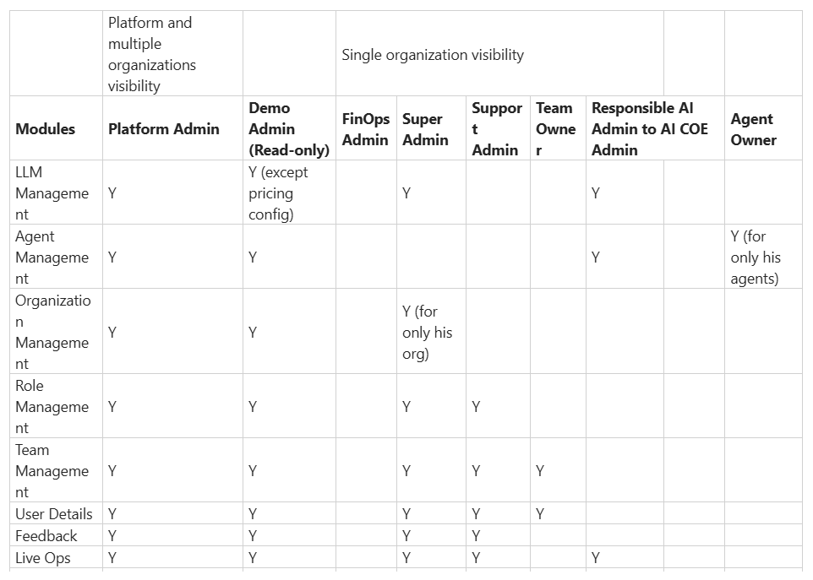
In this application, for authenticating the users we have used Keycloak. It is an Identity and Access Management tool, where inside the administrator console we have created a realm like yashtech_ai, and inside that realm there are certain users, groups are there, so we have created a platform admin group inside that there are members which as access to platform admin role for the organization.
It is a JWT based authentication, where bearer token contains fields like: user_id, organization_id, user_highest_role.
Agent KnowledgeBase
Roles Type: Global,Country and Custom Role
Approval Requests For the Restricted Roles
Invite External Users (Internal and External Organization)

How do you handled multi-tenancy?
We implemented multi-tenancy using organization-based isolation. Each organization has:
Its own users, Teams, Agents, Roles
The organization_id from JWT is used to automatically scope queries, ensuring data isolation.
This prevents cross-organization data access.

Explain a complex feature you worked on?
LLM model configuration is one of the complex feature, and all the agents are dependent on the team’s model configuration. So, what I have done is at first there is an llm management section, inside which we have defined provider level configurations like for Gemini provider there is gemini model and its configurations like api key, versions are defined.
Then in agent management section, we have defined agent level configurations, in which we can select any provider like gemini/claude/gpt etc, so in this way the provider level configurations are set into the agent level llm configurations.
Then in the team llm configurations, the agents that are attached to this team, we synced that agent llm configs to the teams.
So the challenges that I’ve faced are:
- API key masking
- Encryption for the configuration inside db
- Syncing of agent llm configurations with team llm configurations
How do you ensure security?
- JWT authentication
- RBAC implementation
- Encryption of sensitive data
- API key masking
- No sensitive data is returned in APIs
- CRON endpoints use a separate secret
How do you handle scalability?
- Background tasks for async processing
- Pagination for large datasets
- Modular architecture for independent scaling
Tell me a challenge you faced?
One challenge was managing role-based data scoping across multiple organizations.
SUPER_ADMIN has controlled org-level access, ADMIN has access of role, user, and team management.
TEAM_OWNER can see there owned teams only, AGENT_OWNER can see there owned agents only.
We solved this by:
Embedding organization_id in JWT
Enforcing highest role validation at API level
This ensured both security and scalability.

